Springboard Data Analytics Course

Milestone Report 1A for Capstone II

Ontime and Overdue Boston 311 Calls

October 2019

John L. Parsons

**Map of the Wards and Precincts in Boston Massachusetts**

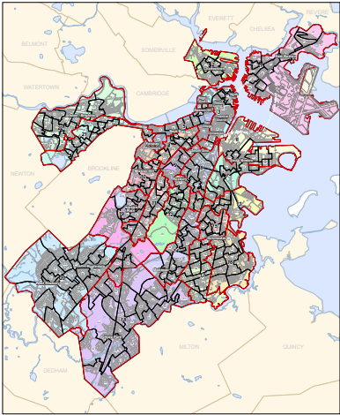

Contents

**Introduction** 3

**1.1 Problem Statement** 3

**1.2 Dataset Summary** 5

**Data Wrangling** 7

**2.1 Missing Data Points** 7

**2.2 Transforming and Binning** 8

**2.2 Time Stamp** 15

**2.3 Geo Pandas** 16

**3.0 Correlation Analysis** 17

**Bivariate and Time-Date Analysis** 18

**4.1 Bivariate Analysis** 18

**4.2 Time-Date Analysis** 22

Modeling 25

**References** 25

**Appendix** 26

# **Introduction**

## **1.1 Problem Statement**

Boston Massachusetts paid the fifth highest property tax rates compared to the other 49 states and their average property tax rate was 6,019 dollars based on a 2018 survey. New Jersey had the highest tax rate at 8,780 dollars per home and Alabama had the lowest tax rate of 788 dollars per home in this study. Boston Residents pay 15.48 dollars per 1,000 of the assessed property values and this amount is up 0.38 cents from the previous year. In a recent poll in Iowa, the majority of Iowans want more accountability and transparency in their tax bills and “believe it is time to tackle the issue of high property tax” as tax rates continue to increase every year for most states. This internal study will be the first of several audits that will be conducted from an independent agency to show the residents a more accountable and transparent government.

This audit will conduct a three-year audit for all 311 Boston Calls made from October 1, 2017 to October 31, 2019 to determine how many calls were completed ONTIME compared to OVERDUE Calls for this three-year period. 311 Boston is a Government service that connects Boston Residents with highly trained Constituent Service Representatives for all non-emergency City Services and the goal of this study is to determine how effective this agency is in completing non-emergency issues ONTIME and within budget. The four milestones for the Internal Audit are;

1. Determine the time it takes to complete the 311 calls in Boston from problem areas for OVERDUE Calls. The length of time for these calls will be compared to San Francisco and Chicago to determine if Boston’s completion time for problem areas is similar to other cities or they are significantly longer.
2. Develop a champion machine learning model that will accurately predict which 311 calls made from Boston Residents have a higher probability for not being completed on time. The higher risk calls will be forwarded to the special task force that will be qualified to handle problem cases to minimize the time it takes to complete these cases.
3. Map specific locations using the latitude and longitude coordinates with Geo Pandas for select overdue 311 Calls in the Boston Area to determine if location may be a factor in length of time for closing these cases.
4. The Final Report will list possible areas that can be improved on to cut cost and time it takes the city to service these calls and be more efficient to the public.

This Internal Audit will contain three phases. The first phase will contain the Milestone Report 1A. This report will be the data exploratory phase and will list the dataset selected for the study, all data wrangling steps used to process the data and the univariate and bivariate analysis of the variables. The second phase will contain the model development of the project and will provide the champion model that will be used to determine completion time for this study, comparison of the length of time to complete projects for Chicago and San Francisco areas and Geo Pandas maps of overdue calls. The Final Report will contain the condensed version of Millstone Reports 1A and 1B, the results from the internal audit and the recommendations to reduce overdue completion time.

## **1.2 Dataset Summary**

The 311 Boston Open Source Data file can be found from the following website: <https://data.boston.gov/dataset/311-service-requests/resource/2968e2c0-d479-49ba-a884-4ef523ada3c0>. The 311 Service Requests was created by the City Constituent Relationship Management System (CRM) in 2011 and is updated daily. The 311 Boston open source data currently contains a total of 1,629,245 data entries and the data file contain 30 attributes. This study will only review the data from October 1, 2017 until the October 31, 2019 and this data file contains a total of 267, 312 entries of data. The Data Quality Report can be seen in Figure 1A, 2A and 3A and shows a list of the original variables and the ones that have been transformed to complete the analysis for this audit. All attributes that end with a _t, _t1 or _t2 have been transformed and will be discussed in the data wrangling section of this report. The following is a brief description of the data set and the description can be seen in Figure 2.

The ontime variable is a categorical attribute and will be the target variable for this study. This is a binary target variable and has been transformed to ontime_t to convert the text to a binary value. The ontime_t value will be represented with a level of 0 and the overdue value will be represented with a value of 1. This is an imbalanced dataset and level 0 contains a total of 217,761 rows of data and level 1 only contains 49,708 rows of data. The remaining 29 attributes contains a total of 21 categorical variables ranging from a binary to a multifactorial variable, four numerical attributes, three dates and one Boolean attribute for the data set.

The 29 input variables can be divided into location, time, description and unique identifiers. The location input variables had many different levels of descriptions such as the physical location of the event or the district the event took place.

**Figure 1: Bar plot of the Target ontime_t variable.**

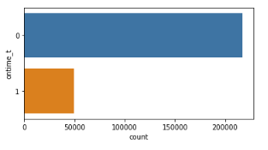

**Figure 2: Boston 311 Description of the 30 Attributes.**

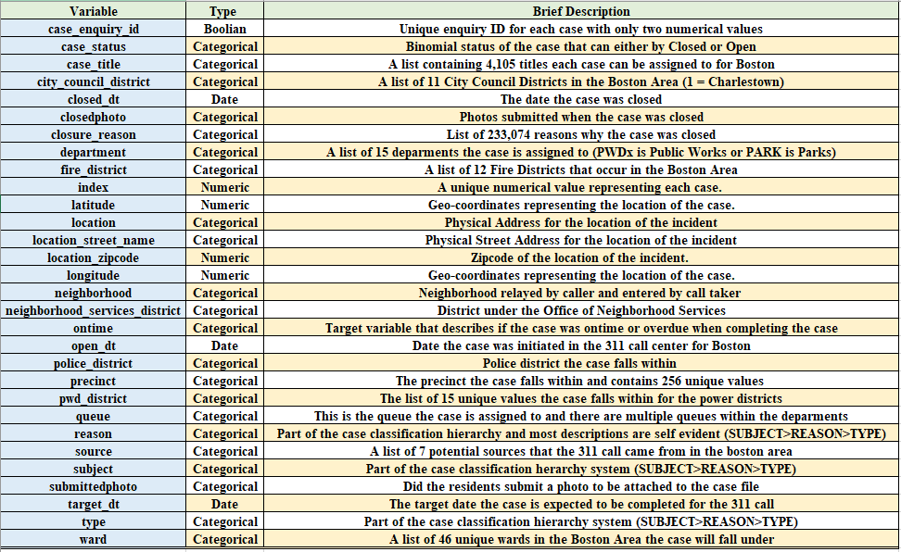

The specific location was recoded as the latitude, longitude, location, location_street_name, and location_zipcode for the 311 events. The district location was divided up into a total of five districts found in the Boston Area. These five districts are; city_council_distict, fire_district, neighborhood_services_distict, police_district and pwd_district. The last type of description for the 311 calls was placed into a case hierarchy system. This hierarchy system was subject (denotes which department the case is assigned to), the reason of the incident and then the type of incident that occurred. The time attributes for the Boston 311 dataset were given as the open_dt, target_dt and the closed_dt of the event for the dataset. The open_dt is the time the 311 case was opened and then the Boston Government gave a specific time the case was expected to be completed and the closed_dt is the time the case actually took to complete. The unique identifiers for the dataset was the index, case_enquiry_id and case_status. The dataset also contained photos of the event if submitted by Boston residents and government officials. These input variables were submittedphoto and closedphoto. The complete description of the attributes can be seen in Figure 2 and Figures 1A to 3A in the Appendix.

# **Data Wrangling**

## **2.1 Missing Data Points**

The Boston 311 dataset had a total of 16 attributes with missing values and these are; ontime, fire_district, city_council_district, police_district, pwd_district, neighborhood_services_district, neighborhood, location_zipcode, ward, precinct, case_title, closedphoto, location_street_name, submittedphoto, target_dt and closed_dt. The list of the missing values and percent missing can be seen in Figure 4A in the Appendix. The missing values that had counts less than 35 were removed from the data set and these are; ontime, city_council_district, neighborhood_services_distict, ward and case_title. The date and time variables target_dt and closed_dt had a total of 33,600 and 31,983 missing variables and were included in the dataset for descriptive, bivariate and model development phase. The missing values from the target_dt and closed_dt variables were removed for the time analysis section of this report to determine the average number of days it took to complete the case.

There is a total of six input variable that had missing values and were not removed from the dataset. These six input variables with the number of missing values in parenthesis are; fire_district (615), police_district (125), pwd_district (130), neighborhood (325), ward and precinct (194). These attributes with missing values had the missing value replaced with 0 and then were binned into a specific bin called 33. This is the same bin that will be used most of the attributes selected for model development.

## **2.2 Transforming and Binning**

The input categorical variables in the dataset had descriptive names to explain the category like “Traffic Division” for subject or 10A for the pwd_district that needed to be replaced with an integer for analysis. The input variables had a lot of missing values represented with ‘ ‘ or NaN in the dataset that needed to be removed as discussed earlier or binned into a distinct value. The categorical variables also had a lot of sparse categories that will lower model performance and will be binned into a group to help increase model performance. The input variables that were modified with these approaches will be discussed next.

The source variable had a total seven levels ranging from “Self Service” to “City Worker App”. The count for all seven levels can be seen in Figure 3 below. The levels were arranged in alphabetical order and then assigned a number from 1 to 7 and placed in a new attribute called source_t and can be seen in Figure 3. Levels 5 (Maximo Integration) and 7 (Twitter) were very sparse and another variable was created called source_t2 and level 5 and 7 were binned into level 6.

**Figure 3:** **Count plot for the source and transformed source_t variables.**

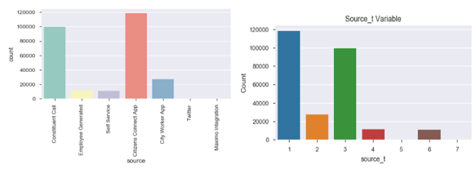

The city_council_district had a total of 10 levels and missing values listed as ‘ ‘ in the data column. The missing value ‘ ‘ was replaced with the number 33. The results from the replacement method and binning of empty values to 33 can be seen in Figure 4. The level 0 for the dataset is also very sparse and was binned into the level 33 and this can be found in the new attribute called city_council_district_t.

**Figure 4. Count plot for the city_council_district variable.**

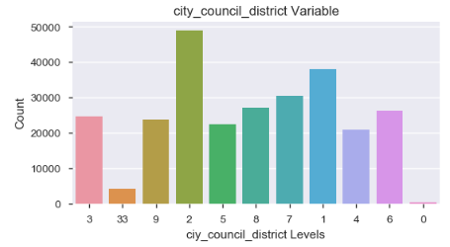

The fire_district had a total of 10 levels and missing values listed as ‘ ‘ and nan in the data column. The missing values ‘ ‘ and nan was replaced with the number 33. The results from the replacement method and binning of empty values to 33 can be seen in Figure 6. The level 10 for the dataset is also very sparse and was binned into the level 33 and this can be found in the new attribute called fire_district_t. The city of Boston has two Fire District Divisions containing 9 Districts and these were placed in new attribute called fire_district_t2. Districts 1, 3, 4, 6 and 11 were placed in Division 1 and 7, 8, 9, 10, 12 and 33 were placed in Division 2 (Figure 6). District 10 is not originally from the two Divisions and 33 is the binned empty values for data set. The names of the districts can be seen in Figure 5A in the Appendix.

**Figure 6: Count plot for the fire_district_t and transformed fire_distirct_t2 variables.**

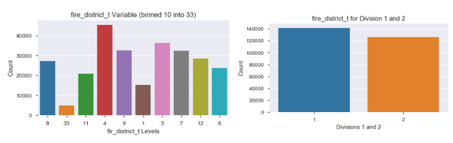

The subject attribute had a total of 11 levels for the data and did not contain any missing values. Figure 7 is a count plot with the original subject names and the distribution of these levels. The subjects were arranged in alphabetical order and then replaced with a value of 1 thru 11 and placed in the new variable called subject_t. The levels 1 to 4 were very sparse and then another attribute called subject_t2 was created and all four of these levels were binned into level 7 to increase model performance.

The pwd_district had a total of 13 unique levels in the dataset and missing values that were binned into level 33 and can be seen in Figure 8. The pwd_district had a mixed set of names which mostly used numbers to represent the district but also contain letters A or B for 1 and 10 pwd_districts. The pwd_district_t was created and the letters from these pwd_districts were replaced with a unique number starting with 20 for 1A to 24 for 10B.

**Figure 7: Count plot for the subject and transformed subject_t variables.**

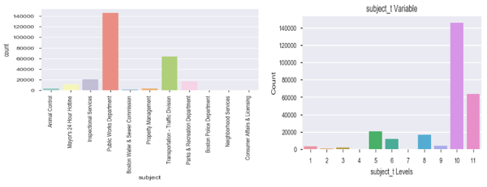

**Figure 8 Count plot for the transformed source pwd_district_t**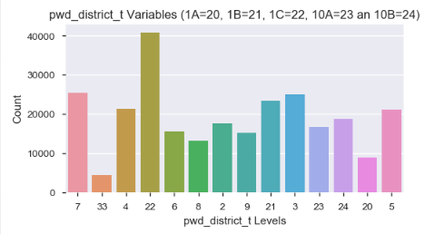

The department attribute had a total of 15 levels and did not contain any missing values for the dataset. The subject was arranged in alphabetical order and replaced with a number 1 for “ANML” up to 15 for “PWDx”. The count plot for the original levels and replaced values can be seen in Figure 9. The department_t2 attribute was created to bin the sparse levels in the dataset. Levels 1, 2, 3, 4 and 7 were all binned into level 8 for this variable. An explanation of these values can be seen in Figure 6A.

The neighborhood attribute contains the name of all 17 neighborhoods (including missing values) relayed by the caller and entered into the data base. This attribute also contained missing values that were replaced with number 33. All values in this variable were integers and will be used for the analysis. Level 0 was very sparse and will be binned into 33 only if this variable is used in the final model.

**Figure 9 Count plot for the department and transformed department_t variables.**

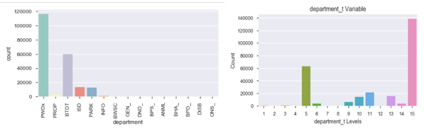

The police district is the location where the case falls within for the Boston residents. There is a total of 12 districts and are labeled as a letter attached to the number. The missing variables were binned into level 33 and then all letters were removed and placed in a new attribute called police_district_t. This can be seen in Figure 10.

**Figure 10 Count plot for the police_district and transformed police_district_t variables.**

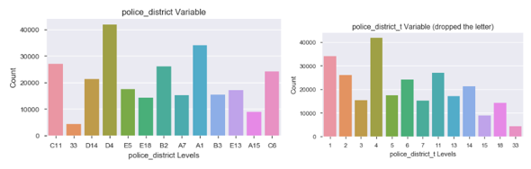

The neighborhood attribute contains the name of all 24 neighborhoods (including missing values) relayed by the caller and entered into the data base. This attribute also contained missing values that were replaced with the name “UNKNOWN”. The attribute neighborhood_t was created and then One Hot Encoding was used to assign specific values to the neighborhoods. The results can be seen in Figure 11 and the names of all the neighborhoods can be seen in Figure 7A in the Appendix. The number of calls for levels 0, 5, 7, 15 and 19 are sparse compared to the other neighborhood levels and will only be binned if this is used as the variable for the final model.

**Figure 11: Count plot for the neighborhood and transformed neighborhood_t variables.**

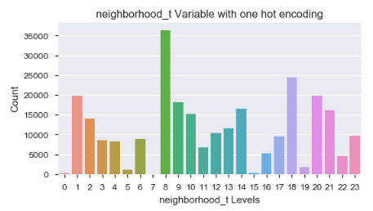

The ward attribute had a total of 44 levels and is the election ward a case will fall into for this variable. There were missing values that were replaced with the word “UNKNOWN”. The wards had an integer designated to the ward or a letter and integer designating each ward. A new attribute called ward_t was created and One Hot Encoding was used to create a unique integer for each ward.

The reason variable was a text describing what the problem was and there is a total of 46 different reasons from the raw dataset but only 26 listed for the last three years. This attribute did not have any missing values and another attribute called reason_t was created and One Hot Encoding was used to create unique numbers for this variable. The list of all reasons can be seen

in Figure 12 and 7A (Appendix).

**Figure 11: Count plot for the 26 different levels listed as a reason**

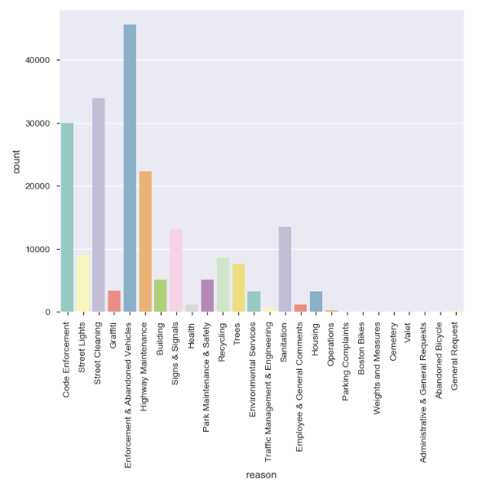

The last two attributes are the type and precinct for this study. The type of complaint had a total of 134 unique categories ranging from “Animal Lost” to “Walk-In Service Inquiry”. There were no missing values for this input variable. A new attribute type_t was created and One Hot Encoding was used to generate unique numbers for analysis. A word cloud will be used in the final report to see which types were used the most for this study. The precinct variable had a total 255 levels and is the Election precinct a case falls within for the 311 calls. There were missing values for this variable and these were replaced with the number 33 and precinct 0502A was replaced with 0502001. A new attribute called precinct_t was created and One Hot Encoding was used to generate unique numbers for this variable.

The last variable of interest was the submittedphoto category and this either had a hyperlink to a picture which could not be uploaded or it was empty with no link to a photo. A new attribute called submittedphoto_t was created and all missing rows of data was given a level of 0 (no photos) and all rows of data with a submitted photo was given a level of 1. Figure 12 shows the distribution of no photos to submitted photos.

Figure 12: Bar plot of the binary submittedphoto_t variable.

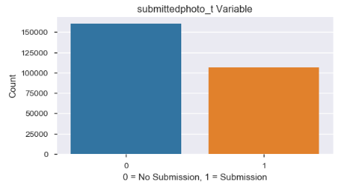

The latitude and longitude attributes had no missing values for the dataset and will be used in the Geo Pandas to map out specific locations from areas that had higher overdue cases and will be compared to ontime cases.

## **2.2 Time Stamp**

The three attributes that were listed as time and date the call was made is classified as an object in python. These three attributes are open_dt, target_dt and closed_dt. The target_dt had a total of 33,600 missing values and the closed_dt had a total for 31,933 missing values. The raw data set was converted to the datetime function and the dataframe was filtered on all rows with an open_dt greater or equal to October 1, 2017 for analysis. The two “time” attributes with missing values were removed and placed in another file called time. There was a total of 207,386 cases and only 28,168 of these were classified as overdue. The time dataset was separated into the on_time and the over_time dataframes and contained either all ontime_t level 0 (ontime) or ontime_t level 1 (overdue) attributes for the time analysis section.

## **2.3 Geo Pandas**

The attributes used for the Geo Pandas was the latitude and longitude for location and the target variable ontime_t. The latitude and longitude attributes did not have any missing values and every call was assigned a specific coordinate. A base map had to be downloaded from the Boston Open Data web site and the two base maps that will be used is the street map and the Fire District map. The data was separated into ontime and overdue cases and the coordinates were plotted for all datapoints in this file and can be seen in Figures 13 and 14.

**Figure 13 Geo Mapping for all ontime cases within the 9 Fire Districts**

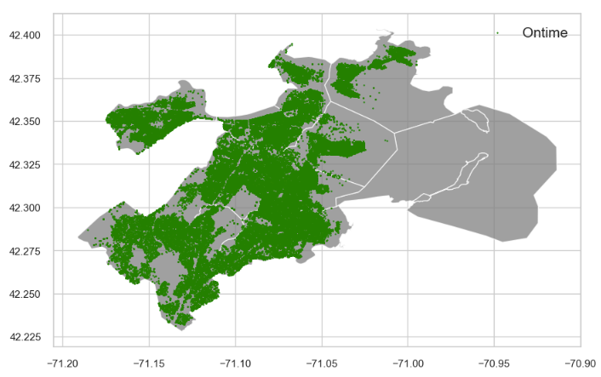

**Figure 14 Geo Mapping for all overdue cases within the 9 Fire Districts**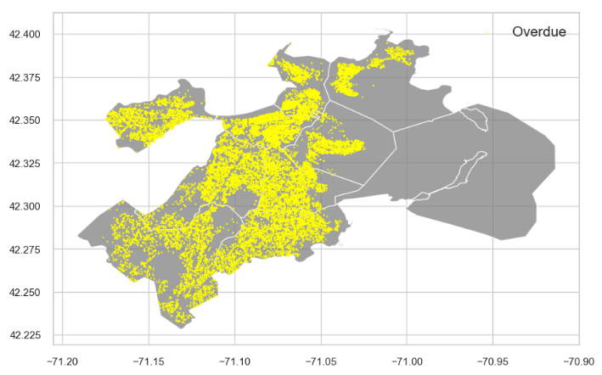

## **3.0 Correlation Analysis**

The pdf file for Boston 311 discusses how several cases could be placed under different attributes such as districts. The correlation cluster map in Python was created to determine which attributes were closely related to each other and will not be used in the final model. The Cluster map can be seen in Figure 15 and the five districts are grouped together and have a higher correlation than the other attributes except for source_t and submittedphoto_t (57%). The city_council_district_t and neighborhood_district_t had a correlation value of 88% and the next highest value was between fire_district_t and city_council_district_t with a value of 76%. The last variable with a high correlation value is fire_district_t and neighborhood_district_t with a value of 71%. These will not be used together in the final champion model to reduce multicollinearity from the dataset.

**Figure 15: Seaborn Cluster Map for 15 variables.**

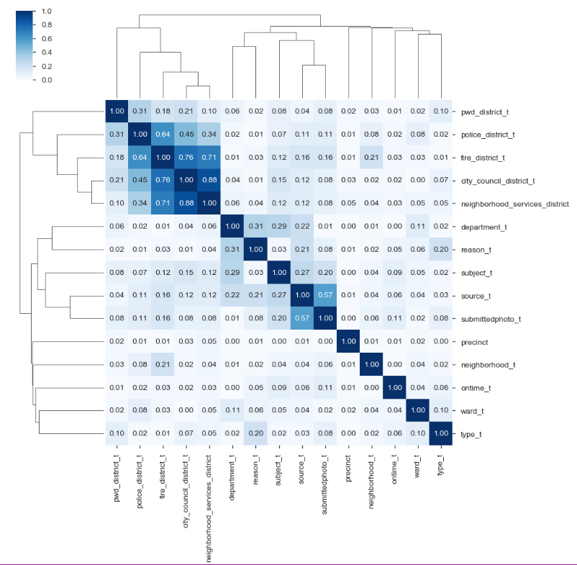

# **Bivariate and Time-Date Analysis**

## **4.1 Bivariate Analysis**

A total of 17 attributes will be used to create the best champion model to predict which cases have a higher probability of becoming overdue. These are; ontime_t, source_t, city_council_district_t, fire_district_t, subject_t, pwd_district_t, department_t, neighborhood_services_district, police_district_t, neighborhood_t, ward_t, reason_t, type_t, precinct and submittedphoto_t. The bivariate analysis section contained the OLS Regression, Tukey Comparison of Means, histogram and normal probability plot, seaborn catplot with ontime_t as the target variable and the pandas cross tabulation table. Graphs were generated in the data wrangling section for all of these 17 variables. The three attributes that will be discussed in this section are the department, subject and reason variables.

The cross tab was graphed and the table was included for the department_t variable and the results can be seen in Figure 16 below. Department_t 10 and 11 had very interesting results

**Figure 16: Catplot and Cross tabulation results for department_t variable and ontime_t**

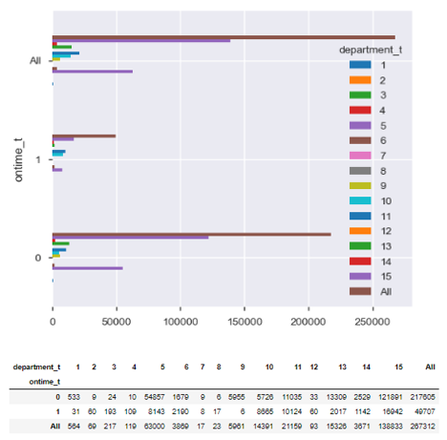

and these departments are the Information Channel (10) and the Inspection Services (11). There were more overdue cases (8,665) than ontime cases (5,726) for the Information Channel and 48% of the cases were overdue for the Inspection Services (10,124) compared to the ontime cases (11,035). There was a total of seven out of nine levels that had significant p values of 0.0 for the OLS Regression Model and both of these were included in this group with t value of 27 and 57. These two attributes contain 18,789 overdue cases out of 49,707 and is close to 38% of the total number of overdue cases and warrants further investigation.

The subject_t has a total of 11 levels containing all 267,312 calls made to the 311 service call center (Figure 17). The two areas that contain the majority of the calls are number 10 which is Public Works Department and number 11 and this is the Transportation – Traffic Division. These two levels contain 70.5% of all overdue cases (35,030).

Figure 17: Count plot and Cross tabulation results for subject_t variable and ontime_t

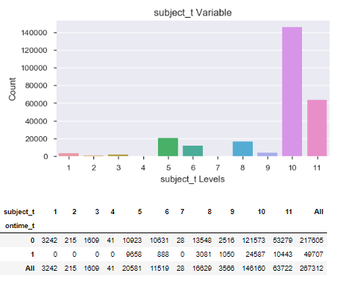

The Boston 311 data set has values that are highly related as show in the correlation matrix cluster plot and have high multicollinearity. The level 10 for subject_t variable is the Public Works Department and is identical to the department_t variable 15. Level 5 is Inspectional Services and is similar to 11 in the department_t category from the previous figure. These variables will not be used together for the final model and will be addressed in the final analysis.

The last variable in this analysis is neighborhood_t to determine if certain locations had more overdue cases. The OLS Regression Results had four levels with a p-value of 0.001 or less in the data set and these are neighborhood_t levels 0, 3, 20 and 21 (Figure 9A). These corresponding neighborhoods are Allston (0), Allston/Brighton (3), South Boston Waterfront (20) and South End Boston (21). There were three more levels with values between 0.001 and 0.05 and were not included in this section. The Seaborn catplot shows the distribution of these attributes and this can be seen in Figure 18. The mean time taken for the ontime and overtime will be calculated and discussed in date-time section of this report.

**Figure 18: Count plot for neighborhood_t and ontime_t**

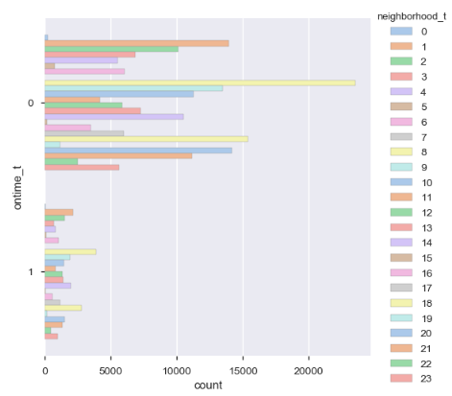

## 

## **4.2 Time-Date Analysis**

The time attributes had the missing values removed and the data set only contains a total of 207,386 rows of data. The total number of ontime cases in this data set is 179,218 and there were only 28,168 cases classified as overdue. There were 21,539 cases that were not closed (missing) and had to be removed to complete the analysis. The mean number of days was calculated from the time the project began and the time it was closed in the dataset. The ontime cases on the average only took 4.1 days to complete compared to 50.6 days for the overtime cases. The ontime variable minimal mean value to complete a case was 0 days compared the longest time to compete the case was 593 days. The overdue variable also had the minimal mean value of 0 days to complete the project and 738 days for the longest time to complete the project. The time-data analysis will discuss the mean number of days to complete for the department_t and neighborhood variables and the box and whisker plot for the subject variable.

The time dataset was separated into two groups and the on_time contained all the ontime variables and the over_time contained all the overdue cases. The number of days it took to close a project was calculated and placed in the close_open_diff column and the number of days it took to complete an overdue project was placed in the target_close_diff column for analysis. The groupby function and graphs for the department and neighborhood can be seen in Figures 19 and 20. Figure 19 shows the PARK department had the longest mean time to complete the ontime case which was 40.03 days and the ANML had the quickest time of 0.0 mean days. The longest mean days to complete the overdue cases was DISB with 288.25 days and the BHA_ had the lowest level with only 2.0 mean days to complete. The DISB is the Disability Commission and only contained a total of 10 cases, but had the longest time for the dataset.

**Figure 19: Graphs for mean number of days of completed and overdue cases.**

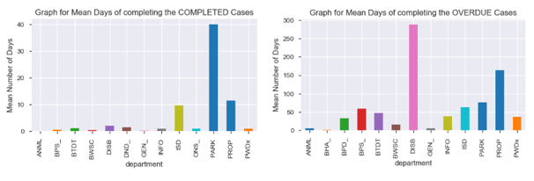

The OLS Regression model showed that neighborhood_t levels 0, 3, 20 and 21 had significant p values of 0.001 or less and the mean time to complete the case was graphed and can be seen in figure 20. The one level that stood out the most was level 0 and this had a total of 225 cases that took on the average of 6.8 days to complete ontime, compared to 43 cases that took on the average 89 days to complete for overdue cases. The other three neighborhoods had an average ontime completion time between 3 to 5 days compared to 43 to 57 days for the overdue cases. Level 0 is the Alston Neighborhood and will be plotted in Geo Panda to determine if specific locations are more difficult to complete ontime.

**Figure 20: Mean number of days for completed and overdue cases for department.**

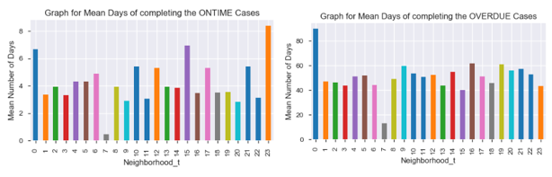

The Box plot was created for the subject attribute with the ontime and overdue cases and this can be seen in Figure 21. The ontime case mean for the Parks and Recreation was 39.9 days and the remaining four levels ranged from 1 to 11.6. The overdue case average for the property management was 169 days and the remaining five levels were ranging between 36 to 76 days for the dataset. All six overdue subjects had a lot of outlierss in the dataset. The outliers for both distributions will be further analyzed in the results section to try and determine the possible cause of these datapoints that take more than 200 days to complete for the Boston area. The two areas of concern are the Transportation-Traffic Division and public works Department which contain around 70% of the overdue cases.

**Figure 21: Box plot for ontime and overdue cases for the subject variable.**

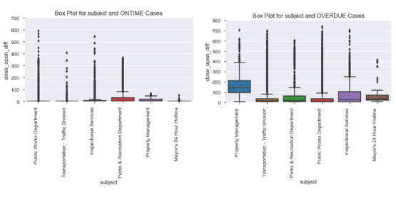

# **Modeling**

(Please note this section will be completed for Capstone II Report 1B)

# **References**

Albon, C. (2018). Machine Learning with Python Cookbook, Practical solutions

preprocessing to deep learning. O’Reilly Media Inc in Boston, First Addition.

Analyze Boston. (ND). 311 Service Requests. Retrieved

from: <https://data.boston.gov/dataset/311-service-requests/resource/2968e2c0-d479-49ba-a884-4ef523ada3c0>

Hastie, T., Tibshirani, R. and Friedman, J. (2017). The Elements of Statistical Learning: Data

Mining, Inference and Prediction. Springer Series in Statistics, 2nd Edition.

Hendrickson, J. (2019). Property Taxes Need Accountability and Transparency.

Retrieved from: <https://caffeinatedthoughts.com/2019/04/property-taxes-need-accountability-and-transparency/>

Patch.com. (ND). 2019 Residential Property Tax Rates for the 351 MA Communities

Retrieved From: <https://patch.com/massachusetts/boston/ma-residential-property-tax-rates-each-community>

# **Appendix**

**Figure: 1A Data Quality Report for Numerical Attributes.**

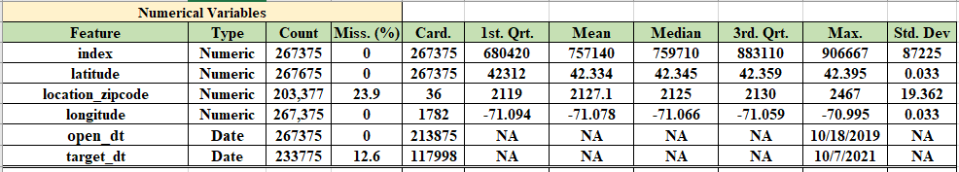

**Figure 2A: Data Quality Report for Categorical Attributes.**

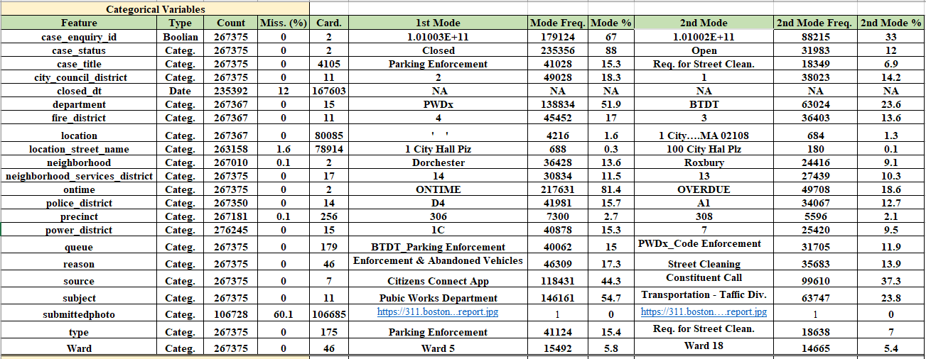

**Figure 3A: Data Quality Report for Transformed Categorical Attributes.**

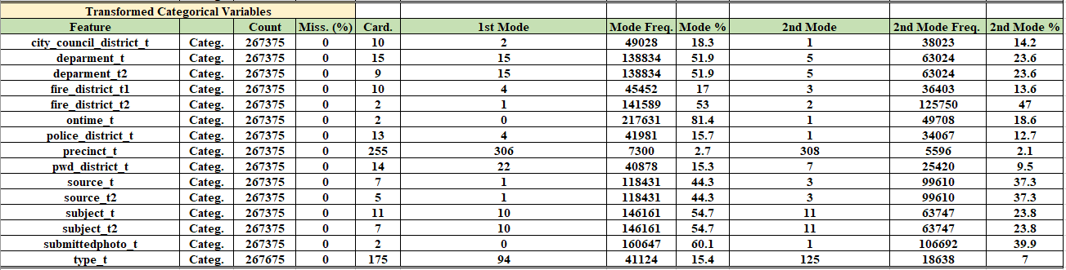

**Figure 4A: Unique Counts and Missing Value Report.**

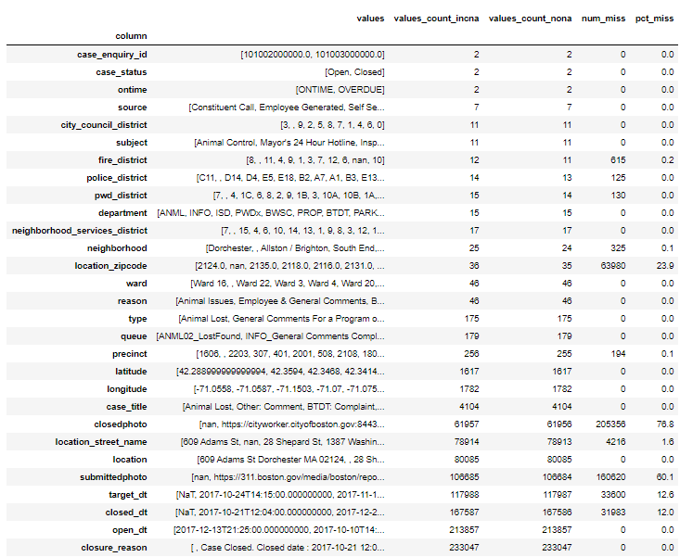

**Figure 5A: Description of the two Boston Divisions.**

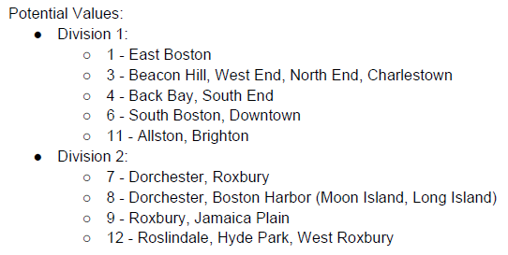

**Figure 6A: Description of the Department Names.**

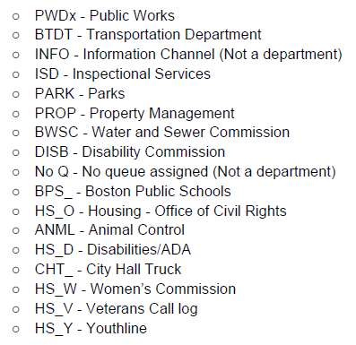

**Figure 7A: Description of the Boston Neighborhoods.**

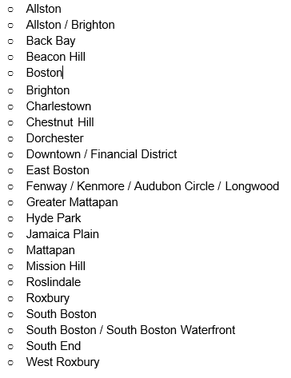

**Figure 8A: List of all 46 Reasons assigned to the 311 Calls.**

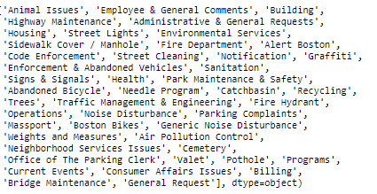

**Figure 9A: OLS Regression Model for neighborhood_t.**

